**Rizwanullah BI PICS**

**Home Assignment – 1**

**DataSet loading :**

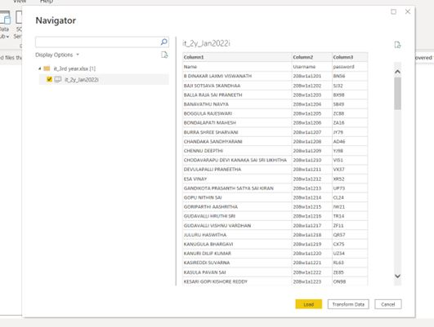

**Visualization of each attribute in dataset**

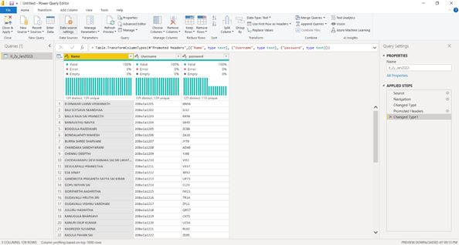

**Final Dashboard :**

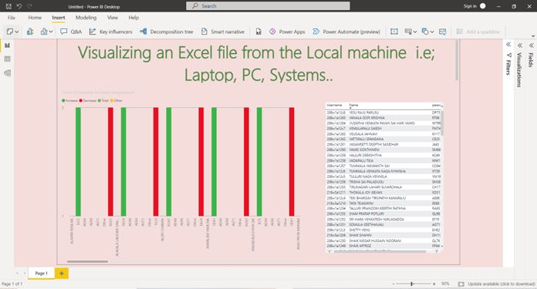

**Home Assignment – 2**

**Dataset Loading :**

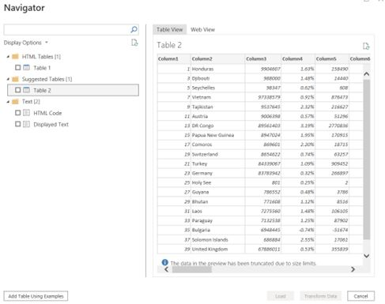

**Replacing Empty and NA Values in DataSet**

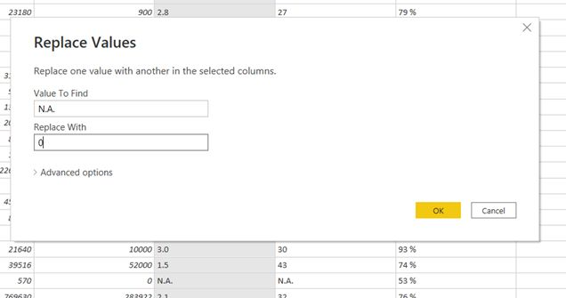

**DataSet after completion of some operations**

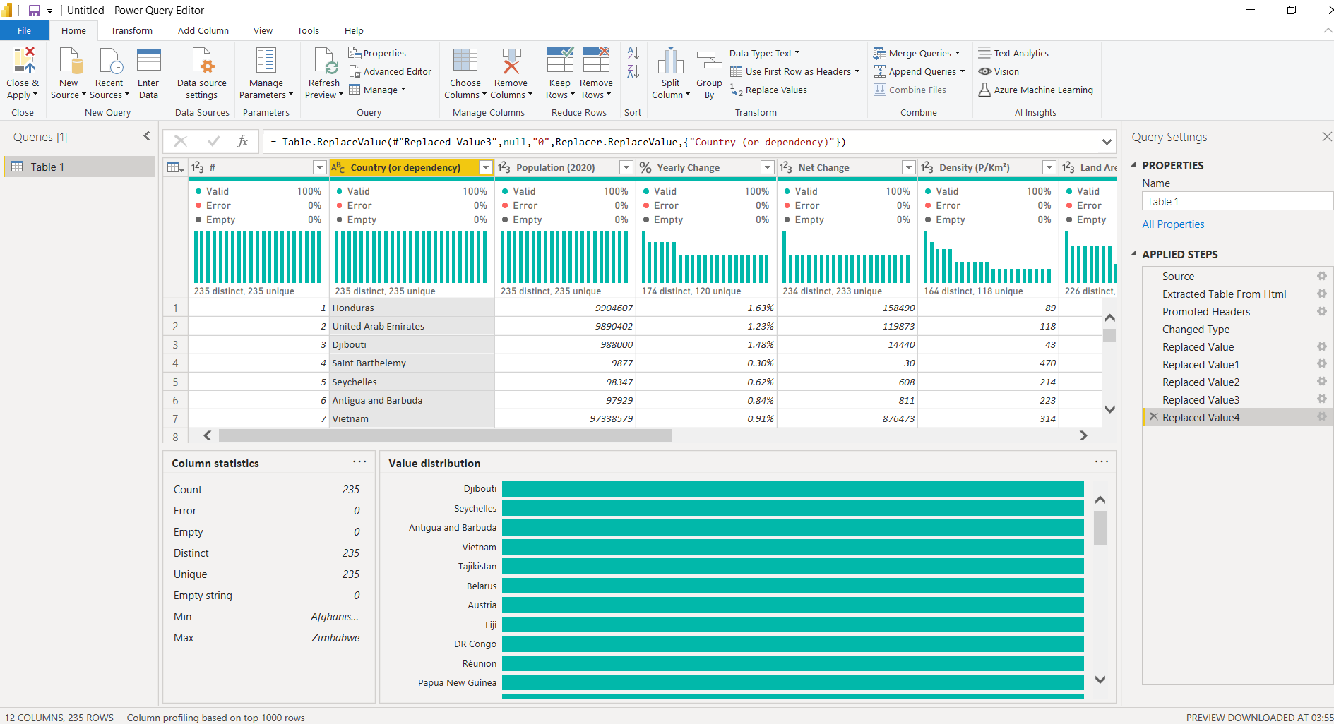

**Final Dashboard :**

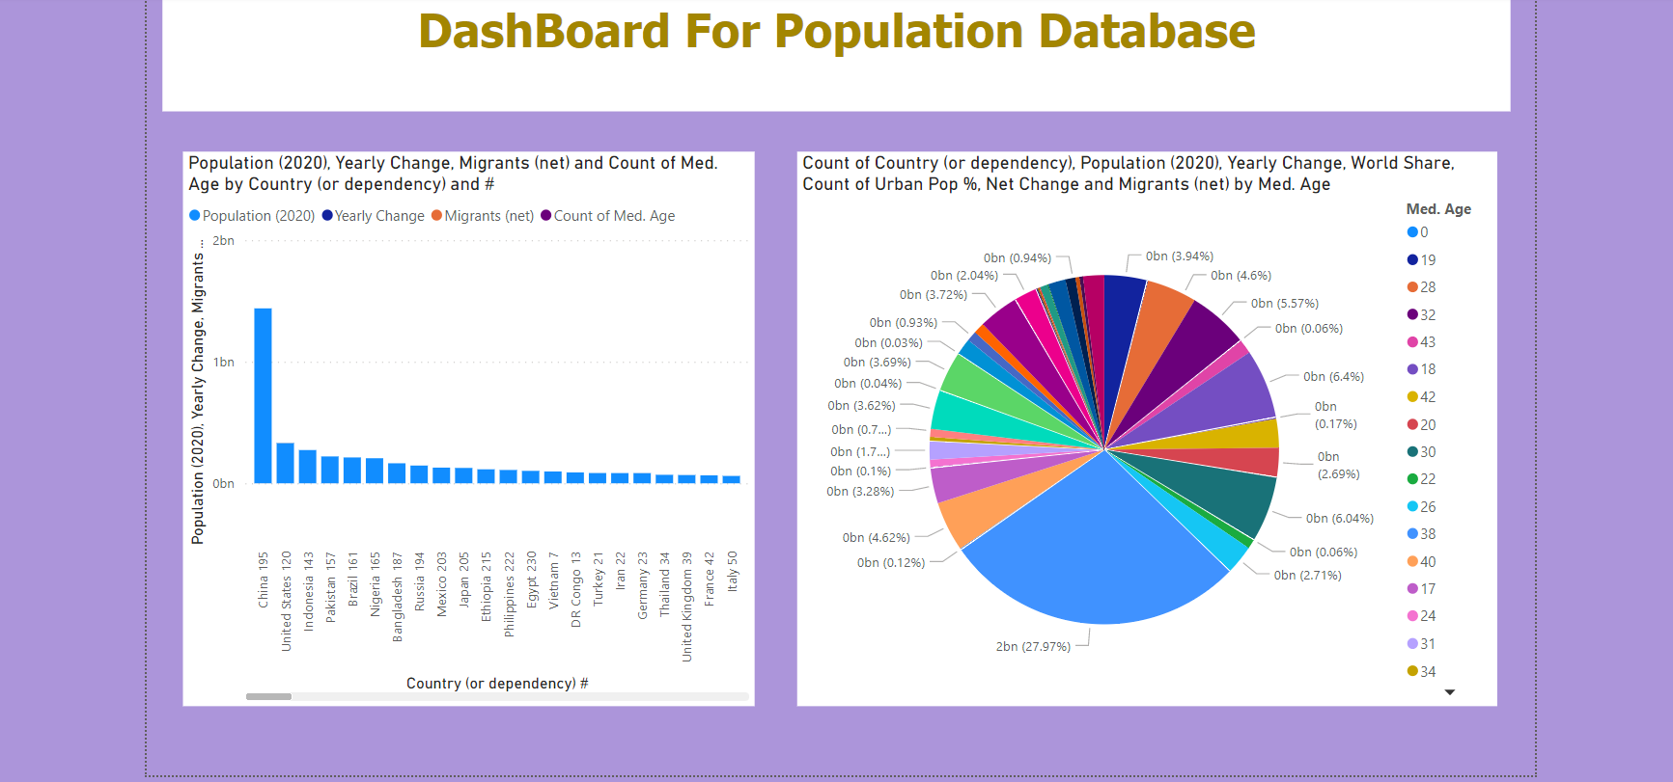

**Home Assignment – 3**

**DataSet Loading :**

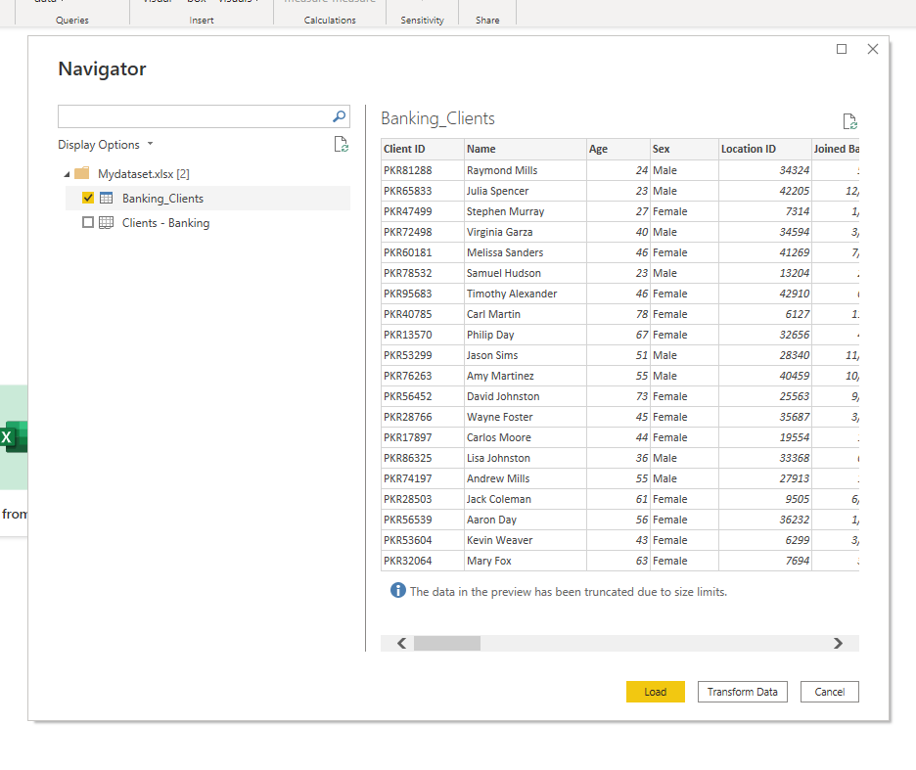

**Adding Conditional Column :**

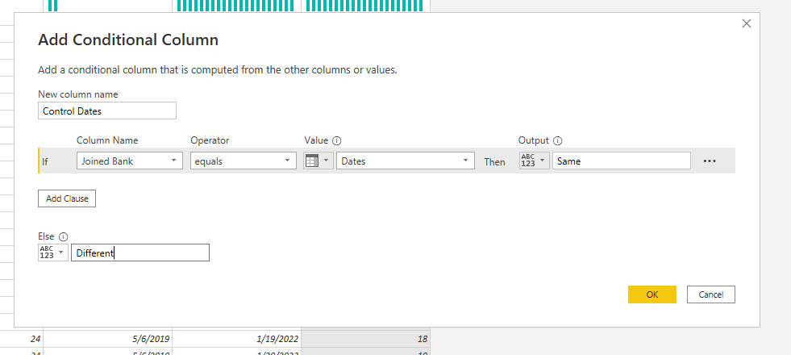

**DataSet Transformation after adding Custom Conditional column**

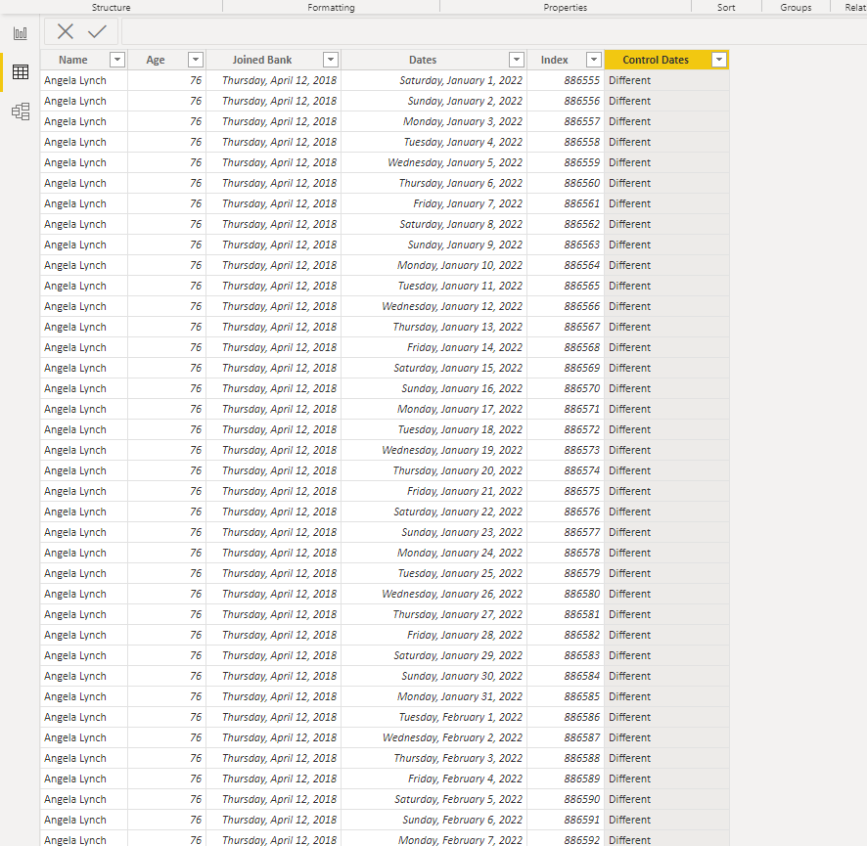

**Final Dashboard :**

